Department of Electrical Engineering
The Superior University, Lahore

Computer Programming

Experiment No.9
Introduction to Multidimensional Arrays

Prepared for:
EISHA NAWAZ
By:
Name: Tanseer Haider
ID: SU91-BSEEM-F25-002
Section: Electrical Engineering Fall 25
Semester: 2nd

Total Marks: ______10_________
Obtained Marks: ______________
Signature: __________________
Date: ________________

Experiment No.9
Introduction to Multidimensional Arrays
(Rubrics)

Name: Tanseer Haider ID: SU91-BSEEM-F25-002

- PSYCHOMOTOR
Serial No. | Criteria | Allocated Marks | Unacceptable  0% | Poor  25% | Fair  50% | Good  75% | Excellent  100% | Total Obtained
1 | Syntax Handling | 1 | 0 | 0.25 | 0.5 | 0.75 | 1
2 | Program Coding Skills | 2 | 0 | 0.5 | 1 | 1.5 | 2
3 | Accuracy in Output Results | 3 | 0 | 0.75 | 1.5 | 2.25 | 3
Sub-Total |  | 6 | Sub Total Marks Obtained in Psychomotor (P)

- AFFECTIVE
Serial No. | Criteria | Allocated Marks | Unacceptable  0% | Poor  25% | Fair  50% | Good  75% | Excellent  100% | Total Obtained
2 | Lab Report | 2 | 0 | 0.5 | 1 | 1.5 | 2
3 | Assigned Task | 2 | 0 | 0.5 | 1 | 1.5 | 2
Sub-Total |  | 4 | Sub Total Marks Obtained in Affective (A)

Instructor Name: | EISHA NAWAZ | Total Marks (P+A): | ______10________
Instructor Signature: | ______________ | Obtained Marks (P+A): | ______________
Contents of Lab 9
1 Objectives 4
2 Multidimensional Arrays in C++ 4
2.1 Declaration of Multidimensional Arrays 4
2.1.1 One-dimensional array: 4
2.1.2 Two-dimensional array: 4
2.1.3 Three-dimensional array: 5
2.1.4 Four-dimensional array: 5
2.2 Visualizing Multidimensional Arrays 5
2.2.1 One-dimensional array: 5
2.2.2 Two-dimensional array: 5
2.2.3 Three-dimensional array: 6
2.2.4 Four-dimensional array: 7
2.3 Calculating The Total Number of Elements in Multidimensional Arrays 8
2.3.1 One-dimensional array: 8
2.3.2 Two-dimensional array: 8
2.3.3 Three-dimensional array: 8
2.3.4 Four-dimensional array: 8
2.3.5 More Examples 8
2.4 Storing And Printing Elements in 2D Array 8
2.4.1 First Method: 8
2.4.2 Better Method: 9
2.4.3 Example 1 (2D Array) 9
2.4.4 Example 2 (3D Array) 10
3 Lab Tasks 11
3.1 Task 1 11
3.2 Task 2 11
3.3 Task 3 11
3.4 Task 4 11
4 Home Assignment: 11
4.1 Task 1 11
4.2 Task 2 11

Introduction to Multidimensional Arrays

Objectives
- To get a basic understanding of multidimensional arrays in C++.
- To understand the working of multidimensional arrays.
- To get hands-on experience working with multidimensional arrays.
- To declare, initialize, and access multidimensional array elements in C++ programming with the help of examples.
- To write C++ programs using multidimensional arrays.

Multidimensional Arrays in C++
Think of a normal (1D) array as a single row of boxes, each box holding one value. A multidimensional array is simply an “array of arrays” boxes arranged in rows and columns (like a table), or even in layers (like a stack of tables). C++ allows for arrays of two or more dimensions. A two-dimensional (2D) array is an array of arrays. A three-dimensional (3D) array is an array of arrays of arrays.
Example: a classroom seating chart. Each seat has a row number and a column number. To find a particular student, you say “row 2, column 3” that is exactly how a 2D array works.

ℹ Tip: A 2D array is just a grid (rows × columns). A 3D array is a stack of grids (like pages in a notebook, each page being a grid).

In C++ programming an array can have two, three, or even ten or more dimensions. The maximum dimensions a C++ program can have depends on which compiler is being used.
More dimensions in an array means more data be held, but also means greater difficulty in managing and understanding arrays.
The general form of declaring N-dimensional arrays:
data_type array_name [size1] [size2] .... [sizeN];

- data_type: Type of data to be stored in the array.
- array_name: Name of the array
- size1, size2..., sizeN: Sizes of the dimensions

From 1D to 3D — Visualized
1D array — a single row of values:
 | col 0 | col 1 | col 2 | col 3
row 0 | 10 | 20 | 30 | 40

2D array — values arranged in rows and columns (a grid):
 | col 0 | col 1 | col 2
row 0 | 0 | 1 | 2
row 1 | 3 | 4 | 5
row 2 | 6 | 7 | 8

3D array: imagine two of the grids above, stacked one behind the other (like two pages). Each page is identified by a “layer” number, and within each page you still use a row and a column.

Declaration of Multidimensional Arrays
There are different ways to declare the arrays consisting of different dimensions. The declaration of each multidimensional array are discussed below:

One-dimensional array:
int one_d_array [2];

Two-dimensional array:
int two_d_array [2][2];

Three-dimensional array:
int three_d_array [2][2][2];

Four-dimensional array:
Int four_d_array [2][2][2][2]

Note: Generally, people use up to a three-dimensional array in programming. In rare cases or for complex scientific purposes they may use up to a four-dimensional array. However, in programming, the arrays can have N number of dimensions.

Visualizing Multidimensional Arrays
The visualization of each multidimensional array are discussed below:

One-dimensional array:
int one_d_array [2];
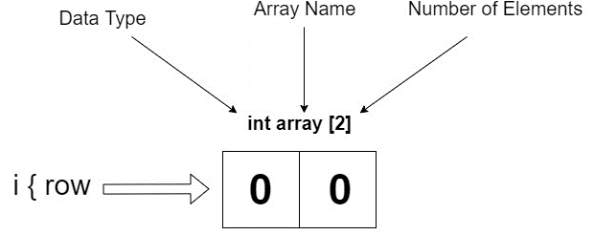

Two-dimensional array:

int two_d_array [2][2];

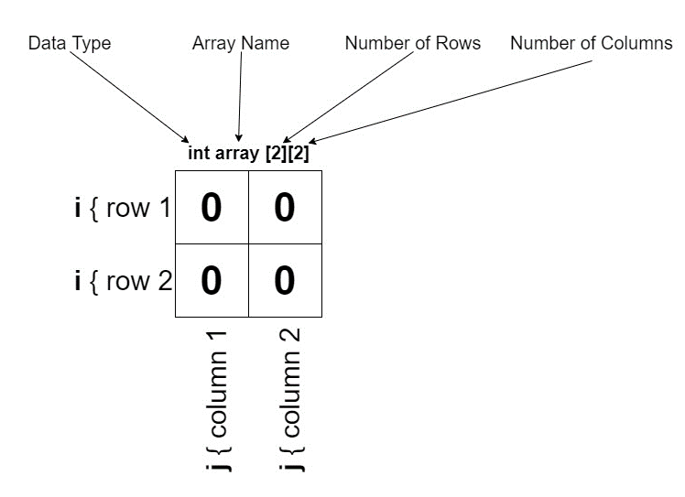

Three-dimensional array:
int three_d_array [2][2][2];
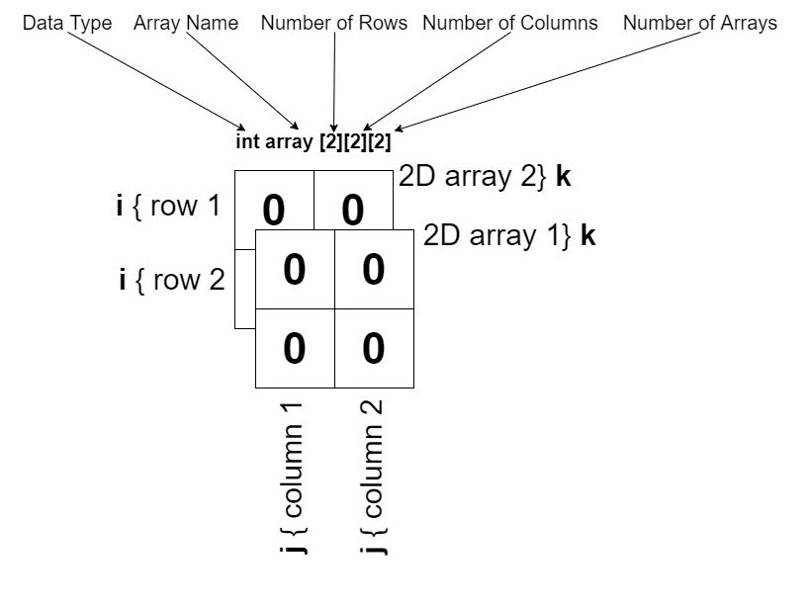

Example 1
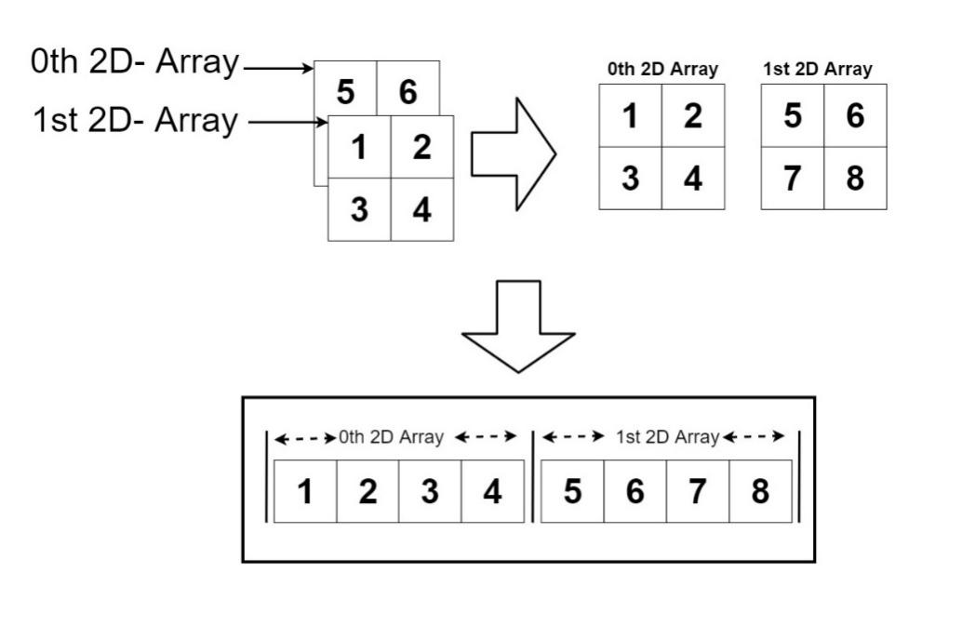

Example 2
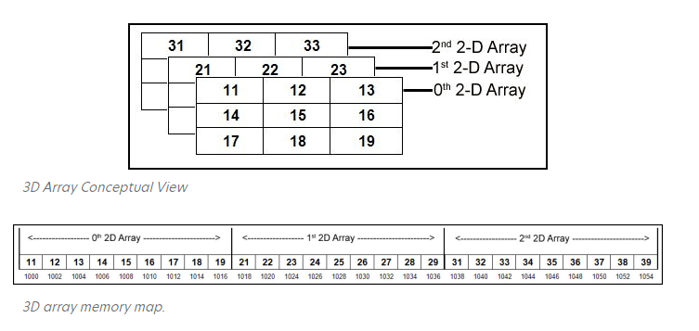

Four-dimensional array:
Int four_d_array [2][2][2][2]
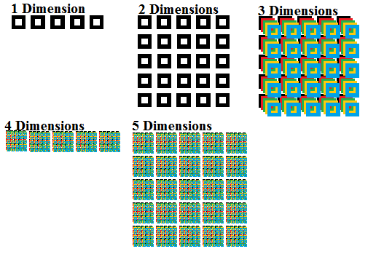

Calculating The Total Number of Elements in Multidimensional Arrays
The arrays can be used in various dimensions depending upon the need such as a 1D array, 2D array, or 3D array. The more dimensions an array has, the more complex it becomes to deal with the programming. Here we discuss the difference between the multidimensional array types.
The General formula for calculating the number of elements is given as follows:
ixjxk…..xN

Dimension | Declaration Example | Total Elements
1D (One-dimensional) | int marks[5]; | 5
2D (Two-dimensional) | int grid[3][3]; | 3 x 3 = 9
3D (Three-dimensional) | int cube[2][3][2]; | 2 x 3 x 2 = 12
4D (Four-Dimensional) | Int four_d_array [2][2][2][2]; | 2x2x2x2=16
ℹ Tip: To find the total number of boxes in any array, just multiply all the sizes together.

More Examples
The total number of elements that can be stored in a multidimensional array can be calculated by multiplying the size of all the dimensions.
For example:
- The array int x[10][20] can store total (10*20) = 200 elements.
- Similarly array int x[5][10][20] can store total (5*10*20) = 1000 elements.

Initializing a 2D Array
There are two common ways to fill a 2D array with starting values.
Method 1: one long flat list (C++ fills row by row automatically):
int x[3][4] = {0, 1, 2, 3, 4, 5, 6, 7, 8, 9, 10, 11};
Method 2: using nested braces, one set per row (easier to read):
int x[3][4] = {
{0, 1, 2, 3},
{4, 5, 6, 7},
{8, 9, 10, 11}
};
Both methods create the exact same array, shown below as a grid:
 | col 0 | col 1 | col 2 | col 3
row 0 | 0 | 1 | 2 | 3
row 1 | 4 | 5 | 6 | 7
row 2 | 8 | 9 | 10 | 11

Accessing Elements — Remember: Counting Starts at 0
This is the part beginners find trickiest, so slow down here. If an array has 3 rows, the row numbers are 0, 1, and 2 — never 3. The same rule applies to columns.
int x[2][1]; // means: row index 2, column index 1
Since indexing starts at 0, row index 2 is actually the 3rd row (2 + 1 = 3), and column index 1 is the 2nd column (1 + 1 = 2).
ℹ Tip: Whenever you see an index like [2], mentally add 1 to get the “human” position: row/column number 3.
To visit every element of a 2D array, use two nested for loops — one loop for rows, one loop for columns:
for (int i = 0; i < rows; i++) {
for (int j = 0; j < cols; j++) {
// x[i][j] is the element at row i, column j
}
}

How 2D Arrays Are Stored in Memory (Row-Major Order)
Even though we draw a 2D array as a grid, computer memory is really just one long line of boxes, one after another. C++ lays a 2D array out row by row; this is called row-major order. The whole first row is stored, then the whole second row right after it, and so on.
For example, the 3x3 grid with values 0–8 (used earlier) is actually stored in memory like this — one long line, row after row (the column label below shows the memory position, 0 to 8):
 | col 0 | col 1 | col 2 | col 3 | col 4 | col 5 | col 6 | col 7 | col 8
row 0 | 0 | 1 | 2 | 3 | 4 | 5 | 6 | 7 | 8
Notice how row 0 (values 0, 1, 2) comes first, then row 1 (values 3, 4, 5), then row 2 (values 6, 7, 8) — all placed one after another in a single line.
ℹ Tip: You never need to manage this yourself — C++ handles it automatically. But knowing that rows are stored one after another explains why the row loop is usually written as the outer loop and the column loop as the inner loop.

Complete Example — 2D Array
This program stores 3 rows and 2 columns of numbers, then prints each one with its row and column position.
#include <iostream>
using namespace std;

int main()
{
// an array with 3 rows and 2 columns
int x[3][2] = { {0,1}, {2,3}, {4,5} };

// print each element with its position
for (int i = 0; i < 3; i++)
{
for (int j = 0; j < 2; j++)
{
cout << "Element at x[" << i << "][" << j << "]: ";
cout << x[i][j] << endl;
}
}
return 0;
}
Output
Element at x[0][0]: 0
Element at x[0][1]: 1
Element at x[1][0]: 2
Element at x[1][1]: 3
Element at x[2][0]: 4
Element at x[2][1]: 5
Dry run — here is exactly what the computer does, step by step, as the two loops run:
Step | i (row) | j (column) | x[i][j] | What gets printed
1 | 0 | 0 | 0 | Element at x[0][0]: 0
2 | 0 | 1 | 1 | Element at x[0][1]: 1
3 | 1 | 0 | 2 | Element at x[1][0]: 2
4 | 1 | 1 | 3 | Element at x[1][1]: 3
5 | 2 | 0 | 4 | Element at x[2][0]: 4
6 | 2 | 1 | 5 | Element at x[2][1]: 5
Notice the pattern: the inner loop (j) finishes completely for one value of i before i increases. This is why the outer loop is often called the “row loop” and the inner loop the “column loop.”

Complete Example — 3D Array
A 3D array just adds one more loop. Think of it as choosing a page (k), then a row (i), then a column (j).
#include <iostream>
using namespace std;

int main()
{
int x[2][2][2] = {
{ {1,2}, {3,4} },
{ {5,6}, {7,8} }
};

for (int i = 0; i < 2; i++)
for (int j = 0; j < 2; j++)
for (int k = 0; k < 2; k++)
cout << "x[" << i << "][" << j << "][" << k << "] = " << x[i][j][k] << endl;

return 0;
}
Output
x[0][0][0] = 1
x[0][0][1] = 2
x[0][1][0] = 3
x[0][1][1] = 4
x[1][0][0] = 5
x[1][0][1] = 6
x[1][1][0] = 7
x[1][1][1] = 8

Common Mistakes to Avoid
These are the errors beginners make most often when they first work with multidimensional arrays. Watch out for them in your own code.
Common Mistake | Why / Fix
Using the same variable name (like i) for both loops. | Each loop needs its own counter. Use i for rows and a different variable, j, for columns, otherwise the inner loop overwrites the outer loop's counter.
Writing x[3][2] and then trying to access x[3][0] on a 3x2 array. | Valid row indexes for 3 rows are only 0, 1, 2. Index 3 does not exist — always loop with < size, e.g. i < 3, never i <= 3.
Forgetting a closing brace } for one of the nested loops. | Every for loop needs its own matching { }. Indent your code consistently so mismatched braces are easy to spot.
Mixing up rows and columns, e.g. writing x[j][i] instead of x[i][j]. | Always keep the order consistent: the first index is the row, the second index is the column.
Declaring int x[3][4] but only initializing 6 values. | The remaining elements are automatically set to 0 — this is usually fine, but double check you meant to leave them as 0.

10. Solved Practice Problem — Sum of All Elements
Problem: Given a 2x3 matrix, find the total sum of all its elements.
Thinking it through: we need to visit every single element exactly once and keep adding it to a running total. A running total needs a variable that starts at 0 before the loops begin.
#include <iostream>
using namespace std;

int main()
{
int x[2][3] = { {1, 2, 3}, {4, 5, 6} };
int sum = 0; // running total, starts at 0

for (int i = 0; i < 2; i++)
{
for (int j = 0; j < 3; j++)
{
sum = sum + x[i][j]; // add each element to the total
}
}

cout << "Sum of all elements = " << sum << endl;
return 0;
}
Output
Sum of all elements = 21
Dry run of the running total:
Step | x[i][j] | sum before | sum after
1 | 1 | 0 | 1
2 | 2 | 1 | 3
3 | 3 | 3 | 6
4 | 4 | 6 | 10
5 | 5 | 10 | 15
6 | 6 | 15 | 21
ℹ Tip: This “running total” pattern (start a variable at 0, then add to it inside a loop) is exactly what you will reuse for the Diagonal Sum task in the Home Assignment.

Self-Check Quiz
Try answering these yourself before checking the answers below — it is the fastest way to know if you are ready for the lab tasks.
- Q1. How many total elements does int m[4][5]; have?
- Q2. What is the index of the very first row and first column in any array?
- Q3. If int a[3][3]; how many nested for loops do you need to print every element?
- Q4. What is the transpose of a matrix?
- Q5. In row-major order, which is stored first: all of row 0, or one element from every row?
Answers:
- A1. 20 (4 x 5).
- A2. 0 (indexing always starts at 0, so the first row/column is index 0).
- A3. Two — one for rows, one for columns.
- A4. A new matrix where every row of the original becomes a column (rows and columns are swapped).
- A5. All of row 0 is stored first, then all of row 1, and so on.

Quick Recap
- A multidimensional array is an array of arrays, 2D is a grid, 3D is a stack of grids.
- Declare with: data_type name[size1][size2]...;
- Total elements = multiply all the sizes together.
- Indexing always starts at 0, not 1.
- C++ stores 2D arrays row by row in memory (row-major order).
- Use one nested loop per dimension to fill or print all elements — outer loop for rows, inner loop for columns (and an innermost loop for the 3rd dimension in a 3D array).
- A running total (a variable started at 0 and added to inside a loop) is a pattern you will reuse often — for sums, counts, and totals.

Storing And Printing Elements in 2D Array
There are two ways to store elements in 2D array depending upon the nature of the programmer.

First Method:
int x[3][4] = {0, 1 ,2 ,3 ,4 , 5 , 6 , 7 , 8 , 9 , 10 , 11}
The above array has 3 rows and 4 columns. The elements in the braces from left to right are stored in the table also from left to right. The elements will be filled in the array in order, the first 4 elements from the left in the first row, the next 4 elements in the second row, and so on.

Better Method:
int x[3][4] = {{0,1,2,3}, {4,5,6,7}, {8,9,10,11}};
This type of initialization makes use of nested braces. Each set of inner braces represents one row. In the above example, there is a total of three rows so there are three sets of inner braces.
Accessing Elements of Two-Dimensional Arrays: Elements in Two-Dimensional arrays are accessed using the row indexes and column indexes.
Example:
int x[2][1];
The above example represents the element present in the third row and second column.
Note: In arrays, if the size of an array is N. Its index will be from 0 to N-1. Therefore, for row index 2 row number is 2+1 = 3.
To output all the elements of a Two-Dimensional array we can use nested for loops. We will require two for loops. One to traverse the rows and another to traverse columns.

Example 1 (2D Array)1````
Code | Output
/ C++ Program to print the elements of a  // Two-Dimensional array  #include<iostream>  using namespace std;  int main()  {  // an array with 3 rows and 2 columns.  int x[3][2] = {{0,1}, {2,3}, {4,5}};  // output each array element's value  for (int i = 0; i < 3; i++)  {  for (int j = 0; j < 2; j++)  {  cout << "Element at x[" << i  << "][" << j << "]: ";  cout << x[i][j]<<endl;  }  }  return 0;  } | Element at x[0][0]: 0  Element at x[0][1]: 1  Element at x[1][0]: 2  Element at x[1][1]: 3  Element at x[2][0]: 4  Element at x[2][1]: 5

Example 2 (3D Array)
Code | Output
// C++ program to print elements of Three-Dimensional  // Array  #include<iostream>  using namespace std;  int main()  {  // initializing the 3-dimensional array  int x[2][3][2] =  {  { {0,1}, {2,3}, {4,5} },  { {6,7}, {8,9}, {10,11} }  };  // output each element's value  for (int i = 0; i < 2; ++i)  {  for (int j = 0; j < 3; ++j)  {  for (int k = 0; k < 2; ++k)  {  cout << "Element at x[" << i << "][" << j  << "][" << k << "] = " << x[i][j][k]  << endl;  }  }  }  return 0;  } | Element at x[0][0][0] = 0  Element at x[0][0][1] = 1  Element at x[0][1][0] = 2  Element at x[0][1][1] = 3  Element at x[0][2][0] = 4  Element at x[0][2][1] = 5  Element at x[1][0][0] = 6  Element at x[1][0][1] = 7  Element at x[1][1][0] = 8  Element at x[1][1][1] = 9  Element at x[1][2][0] = 10  Element at x[1][2][1] = 11

Lab Tasks
Three-Phase Voltage Monitoring System
A substation engineer needs to monitor the voltage of a 3-phase power line (Phase A, B, C) recorded every hour over 2 days. The safe operating range is 210V–230V. You will store this data in a 3D array and analyze it for averages and abnormal (over/under-voltage) conditions exactly the kind of dataset a SCADA logging system produces.

Concepts Covered in This Lab
- Declaring and initializing a 3D array: array[day][phase][hour]
- Traversing a 3D array with three nested loops
- Reducing along one dimension (averaging across hours)
- Tracking a maximum/minimum value together with its index position
- Conditional flagging of values while traversing a 3D array

Starter Code
Complete the TODO sections directly inside main(). Do not create any additional functions every operation must be written using nested loops and conditionals inside main().
#include <iostream>
using namespace std;

int main() {
// 3D array: voltage[day][phase][hour]
// day: 0-1 -> Day 1, Day 2
// phase: 0-2 -> Phase A, Phase B, Phase C
// hour: 0-23 -> hour of the day
int voltage[2][3][24] = {
// ---------------- Day 1 ----------------
{
{218,219,220,221,222,223,224,225,226,227,228,229,230,229,228,227,226,225,224,223,222,221,220,219}, // Phase A
{215,216,217,218,219,220,221,222,223,224,225,226,227,228,229,230,231,232,233,232,231,230,229,228}, // Phase B
{200,205,208,210,212,215,218,220,222,224,226,228,230,232,234,209,208,207,206,205,204,203,202,201} // Phase C
},
// ---------------- Day 2 ----------------
{
{220,220,220,220,220,220,220,220,220,220,220,220,220,220,220,220,220,220,220,220,220,220,220,220}, // Phase A
{225,226,227,228,229,230,231,232,233,234,235,234,233,232,231,230,229,228,227,226,225,224,223,222}, // Phase B
{195,198,201,204,207,210,213,216,219,222,225,228,231,234,237,208,207,206,205,204,203,202,201,200} // Phase C
}
};

int i, j, k; // i = day, j = phase, k = hour
char phaseName[3] = {'A', 'B', 'C'};
int lowLimit = 210, highLimit = 230;

// ---------- TODO 1: Display the full dataset ----------
// Use three nested loops (i, j, k) to print every reading in the format:
// "Day 1 - Phase A - Hour 0 : 218 V"

// ---------- TODO 2: Average voltage per phase, per day ----------
// For each day (i) and each phase (j), sum voltage[i][j][k] over all
// 24 hours (k), divide by 24, and print the result.

// ---------- TODO 3: Overall maximum and minimum voltage ----------
// Scan the entire 3D array and keep track of the largest and smallest
// value found, AND the (day, phase, hour) at which each occurs.
// Print: "Max voltage = ___ V on Day ___, Phase ___, Hour ___"

// ---------- TODO 4: Flag abnormal voltage readings ----------
// While traversing the array, if voltage[i][j][k] < lowLimit
// OR voltage[i][j][k] > highLimit, print an alert showing the
// day, phase, hour, and the out-of-range value.

return 0;
}

Sub-Tasks
Task 1: Display the dataset
Use three nested loops to print every single reading in the array in a clear, labeled line (Day, Phase, Hour, Voltage). This confirms you can address any element of a 3D array with three independent indices.
Task 2: Per-phase, per-day average
For every (day, phase) pair, add up all 24 hourly readings and divide by 24. This introduces reducing a 3D array down to a 2D result by collapsing one dimension.
Task 3: Global maximum and minimum with location
While looping through all elements, compare each value to a running max and running min. Every time you update the max/min, also store the current i, j, k so you can report exactly where the extreme value occurred.
Task 4: Abnormal voltage flagging
Combine traversal with a conditional check: any reading below 210V or above 230V should trigger a printed alert. Confirm your program catches the abnormal values that were intentionally placed in Phase C's data.

Expected Outcome
- A full printed table of 144 readings (2 days × 3 phases × 24 hours).
- 6 average values printed (2 days × 3 phases), each close to but not exactly 220V.
- One clearly identified maximum reading (Phase C reaches into the high 230s) and one minimum reading (Phase C dips into the 190s), each with its exact day/phase/hour.
- Several abnormal-voltage alerts printed for Phase C entries that exceed 230V or fall below 210V on both days.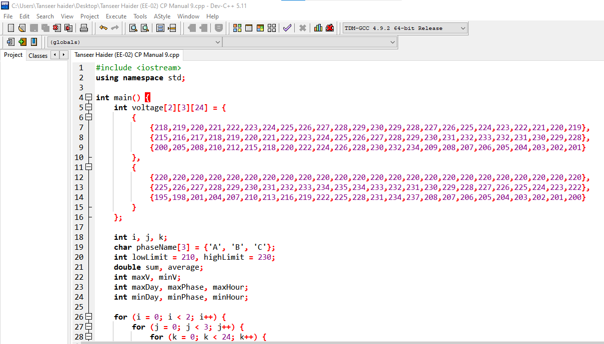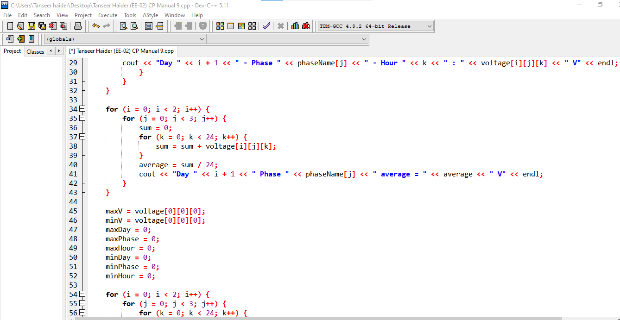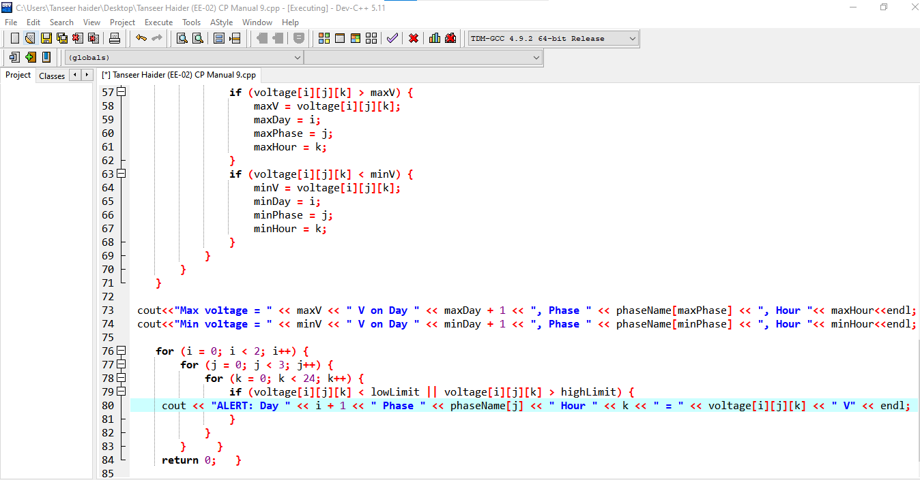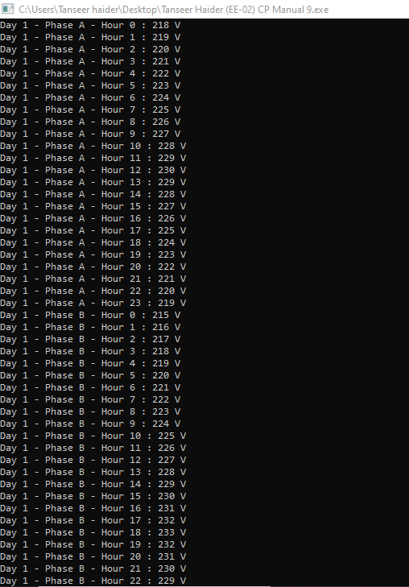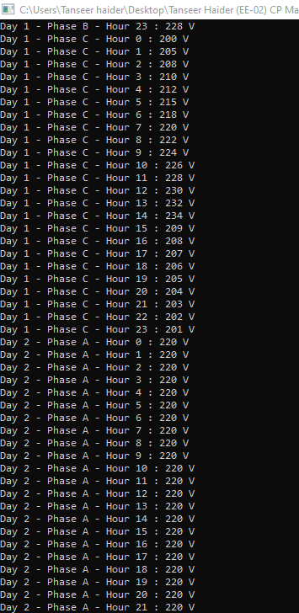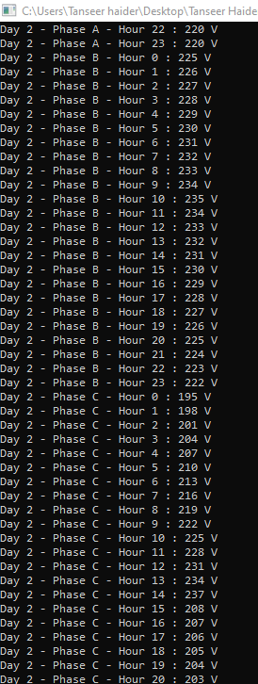
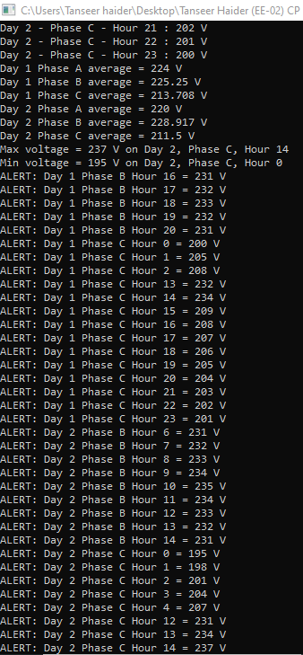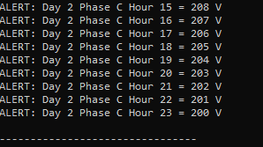

Hands-On Practice Exercises (Do Independently)
Write these as separate standalone programs, without looking back at the starter code, to test your own grasp of the concept.
- Create a 2D array temp[3][7] holding one week of daily temperature readings (°C) from 3 different transformer stations. Print which day had the highest temperature at each station.
- Extend the voltage[2][3][24] array in the main lab into voltage[3][3][24] by adding a third day of readings you invent yourself, then re-run the max/min search across all three days.
- Create a 2D array current[4][5] representing current draw (Amps) from 4 feeders across 5 readings each. Print the total current drawn by each feeder.

